Problem 4:

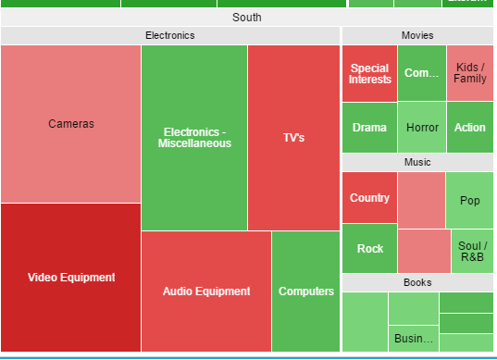

Cameras

The colour is pale which shows the highest revenue.